Immunohistochemistry to detect the presence of
Green Fluorescent Protein in cells, within paraffin sections of mouse tissues.

To track GFP abeled cells in mouse tissue, it is best to plan to extract the tissue as on the protocol on mousepheno website. With this one can more accurately quantify the infiltrating cells. See reference:
Borsig L, Wong R, Hynes RO, Varki NM, Varki A. Synergistic effects of L- and P-selectin in facilitating tumor metastasis can involve non-mucin ligands and implicate leukocytes as enhancers of metastasis. Proc Natl Acad Sci U S A. 2002 Feb 19;99(4):2193-8.

But if you do want to perform immunohistochemistry, here is a protocol that may work for you:

A. Tissue Controls:
1. Positive control: Cells or tissue expected to be positive. Positive controls may also be the cells that are know to express the epitope, that are grown in tissue culture up to about 100 million, taken and made into a pellet, fixed, paraffin embedded and sectioned.
2. Negative control: Cells or tissue expected to be negative.
B. Reagent controls:
1. 1% BSA/PBS reagent negative control for secondary reagents
2. Chicken IgY (Jackson #003-000-003, 5.7 mg/ml), use at 1:500 dilution
3. Further controls included staining of cells expressing higher levels of epitope in question, and using the immunizing peptide (1 mg/ml) at a 1:50 dilution to compete out the reactivity of the antibody, resulting in a negative stain.
Reagents:
Chemicals:
To prepare Phosphate Buffered Saline:
1. Sodium Chloride: Vendor: Fisher Catalog# S271-500
2. Sodium Phosphate Anhydrous: Vendor Fisher Catalog# S375-500
3. Sodium Phosphate Monobasic: Vendor Fisher Catalog# S369-500
To de-Paraffinize slides:
1. Xylene Fisher Catalog #: X3P
2. Alcohol Fisher Catalog # : A962F
3. distilled water
To block endogenous non-specific binding sites in tissue sections:
1. Bovine Serum Albumin Vendor: Sigma Catalog # A2153
To remove endogenous peroxidases:
1. 30% Hydrogen Peroxide: Vendor: Fisher Scientific Catalog# H32-100
To block endogenous biotin:
1. Avidin Biotin Blocking kit: Vendor: Vector Labs Catalog # SP2001
To counterstain nuclei:
1. DAPI: Vendor: Sigma Catalog# #D9542-1mg
To mount slides for viewing and photography:
- Vectamount : Vendor: Vector catalog# H5501
Antibodies:
1. Chicken IgY Negative reagent control: Vendor: Jackson catalog # 003-000-003
2. Chicken polyclonal to GFP: Vendor: AbCam catalog # ab13970
3. Biotinylated anti-Chicken: Vendor: Jackson Catalog#703-065-165
4. Cy3 conjugated Streptavidin: Vendor: Jackson Catalog# 016-160-084

To prepare Heat Induced Epitope Retrieval
1. Citric Acid: Vendor: Fisher Catalog# A940-500
2. Sodium Citrate Vendor: Fisher Catalog# S279-500
Prepare 0.01 M Citrate Buffer, pH 6.0:
(41 mL 0.1 M Sodium Citrate, 9 mL 0.1 M Citric Acid + 450 mL MQ Water)

Other materials:
1. Positive control and negative control cells sections
2. Positive control and negative control tissue sections
3. Paper towels UCSD Storehouse #5353
4. Humid Chamber: Vendor: RPI Catalog# 248270
5. Treated frosted slides : Vendor: Fisher Catalog# 12-550-15
6. Coverslips: Vendor Surgipath Catalog# 00150acs
7. Green staining dish for organic solvents Vendor: VWR Catalog Cat.# 25608-904)
8. White staining dish: Vendor: VWR Catalog # 25608-906
9. Slide holder: Vendor: VWR Catalog # 25608-868)
10. Proteinase K Vendor DAKO catalog# S3020

Optimization protocol
Sections on slides pretreated were treated with Heat Induced Antigen retrieval as follows
ANTIGEN RETRIEVAL: Heat Induced Epitope Retrieval (HIER)
a. fill green tub with 0.01M citrate buffer working solution
b. fill slide holder with "dummy" slides and intersperse the test slides among
the dummy slides so that the slide holder is full of slides-this allows even heating
c. cover and place in larger container with water that goes halfway up the tub,
and heat for 5 minutes on high.
d. check levels and repeat a second time, for 5 more minutes
e. remove slide container from microwave, (Careful-IT WILL BE HOT) remove lid
and let the container sit on counter top for 20 minutes, to cool
f. wash in PBS x3
The slides were then washed in washing buffer before proceeding with immunostains

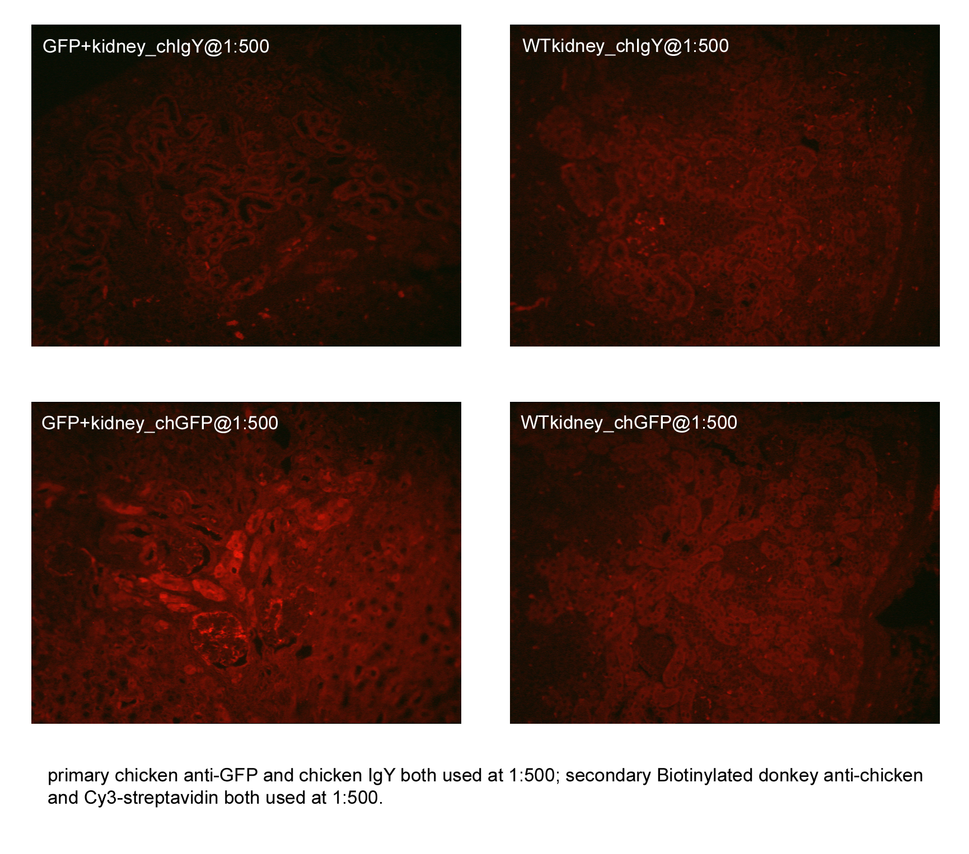
The chicken anti-GFP and chicken IgY control antibodies were both used at 1:500 and 1:1000 dilutions
Results of optimization showed: the chicken anti-GFP antibody works well at 1:500 with HIER. Staining was faint at 1:1000.
Method for immunostaining for GFP in paraffin sections of mouse tissues
1. Label slides with paraffin sections on them to be tested, with date and reagent to be applied and take to the fume hood where the deparaffinization will occur.
2. Make 20 X PBS stock:
a. To 1500 milliliters of MilliQ water with a magnetic stir bar on a stirplate, add using a plastic funnel:
b. 41 grams of Sodium phosphate Anhydrous
c. 15.6 grams of Sodium Phosphate Monobasic
d. 360 grams of Sodium Chloride
Stir to dissolve and make up volume to 2000 ml. Label bottle with constituent, date and initials
3. Make WASHING BUFFER: working 6 liters of 1x PBS pH 7.2
a. 300 milliiters of 20x PBS
b. 5700 milliliters of MilliQ water
c. Label bottle with constituent, date and initials
4. Make BLOCKING/DILUTING BUFFER: 1%BSA in PBS:
a. Measure out 50 milliliters of PBS into a 50 ml Falcon tube
b. Weigh out 500 milligrams of Bovine Serum Albumin and add to the PBS in the Falcon tube, Invert a few times to dissolve completely. Label tube with constituent, date and initials
5. DEPARAFFINIZATION:
a. Xylene green tub# 1 - overnight OR for 10 minutes
b. Xylene green tub #2: for 10 minutes, briefly move rack up and down
---(BMRUAD)---move slide holder up and down so that the slides get "washed" before leaving the slide rack in the tub of xylene for the specified amount of time (10 minutes)
c. Xylene green tub #3: for 10 minutes
6. REHYDRATION:
a. 100% alcohol BMRUAD and then leave for 5 minutes, and repeat one more time
b. Dip into 95% alcohol BMRUAD and then leave for 5 minutes, and repeat one more time
c. Dip into 70% alcohol BMRUAD and then leave for 5 minutes, and repeat one more time
d. Dip into PBST buffer BMRUAD and then leave for 5 minutes, and repeat two more times
7. Block ENDOGENOUS PEROXIDASES
a. Immerse slides in slide holder in 0.3% H₂O₂ (Paraffin sections) in PBST for
30 minutes at room temperature
b. follow this with 3 buffer washes.

8. Block ENDOGENOUS BIOTIN
a. Overlay with 0.1% avidin for 10 - 15 minutes (following manufacturer's suggestions)
b. followed by 3 buffer washes.
c. Overlay with 0.01% biotin for 10 - 15 minutes (following manufacturer's suggestions)
d. followed by 3 buffer washes.

9. ANTIGEN RETRIEVAL: Heat Induced Epitope Retrieval (HIER)
a. fill green tub with 0.01M citrate buffer working solution
b. fill slide holder with "dummy" slides and intersperse the test slides among
the dummy slides so that the slide holder is full of slides-this allows even heating
c. cover and place in larger container with water that goes halfway up the tub,
and heat for 5 minutes on high.
d. check levels and repeat a second time, for 5 more minutes
e. remove slide container from microwave, (Careful-IT WILL BE HOT) remove lid
and let the container sit on counter top for 20 minutes, to cool
f. wash in PBS with BMRUAD x3

10. IMMUNOSTAINING:
a. Primary reagents:
(Primary antibody used at predetermined dilution)
or negative reagent controls) diluted in blocking reagent

Control slides and test slides will receive:
Slide 1: Blocking buffer
Slide 2: Chicken IgY at 1:500 dilution
Slide 3: Chicken anti-GFP at 1:500 dilution
NB: It is very important to determine optimal conditions for using the Primary Antibody by using it
at concentrations varying from 1 microgram/milliliter up to 10 micrograms/milliliter
and by using it under different conditions with and without different antigen retrieval conditions

Document results and consult with supervising Pathologist before proceeding with the assay on test slides. Always include controls with every run

b. Incubate in humidified chamber for the specified length of time. Overnight incubation allows better penetration of antibody into paraffin sections. Remember to coverslip over the reagent on the section, so that the sections will stay covered with reagent, all throughout the incubation and will not dry out at any time, because if any drying occurs, this will contribute to high background.

c. follow this with 3 buffer washes. with washes in between each step.
d. Secondary reagent overlay: biotinylated secondary: Incubate in humidified chamber for the specified length of time follow this with 3 buffer washes
e. Tertiary reagent overlay: labeled Streptavidin: Incubate in humidified chamber for the specified length of time follow this with 3 buffer washes
f. Nuclear counterstain: Overlay with DAPI at 1:40,000 for 5 minutes and follow this with 3 buffer washes
g. coverslip with aqueous mounting media
h. Dry and view for digital photomicrographs

