Preparation TO HARVEST ORGANS
- Prepare yourself with personal protective gown, glasses and gloves
- Prepare FUME HOOD to euthanize animals with authorized container
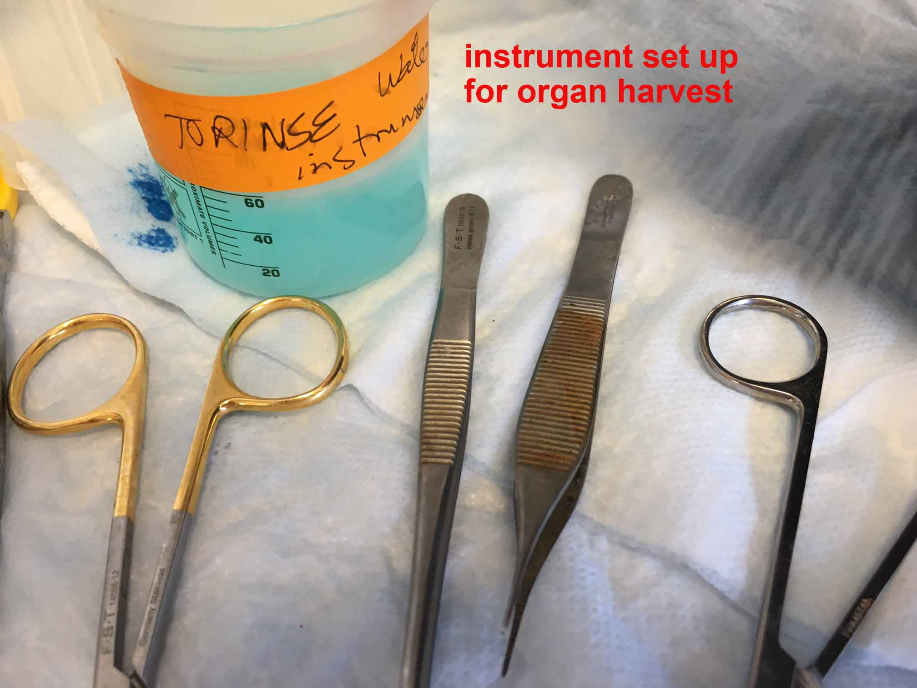
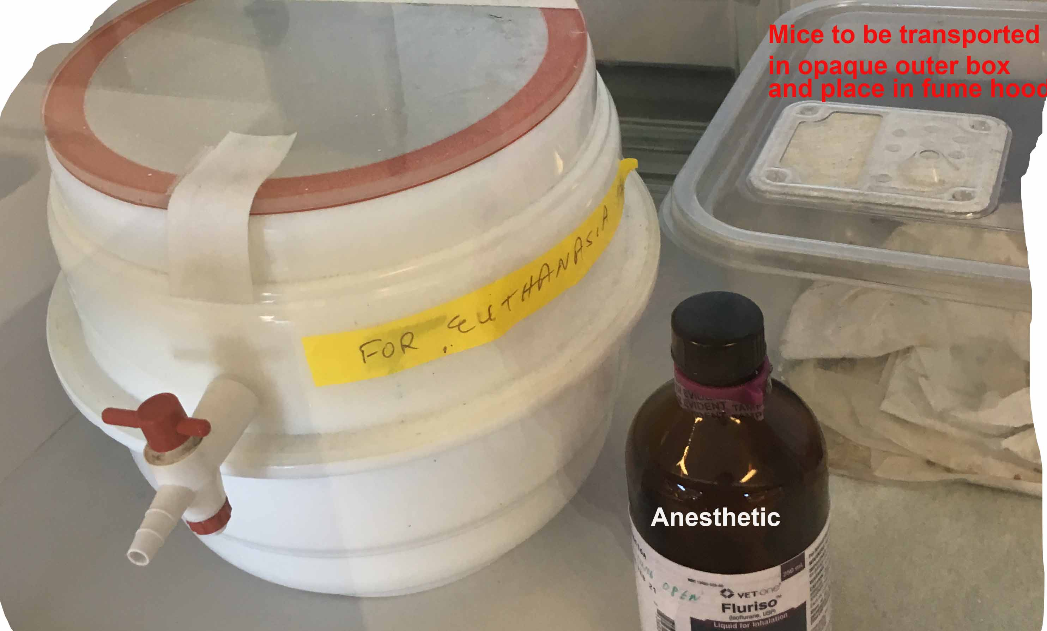

Prepare to freeze samples:
- Bring dry ice to use for 2 styrofoam boxes: One will be the holding box with frozen samples and the other will be for dry ice/2-methyl butane to freeze samples
- Use the small shallow Styrofoam rectangular container to freeze samples
- Pour in some 2-methyl butane
- Add bits of dry ice to make a slurry mixture, to freeze samples in OCT, in vinyl molds.
- Label plastic molds which will hold the portions of different organs from the different animals to be frozen, in the dry ice/isopentane slurry
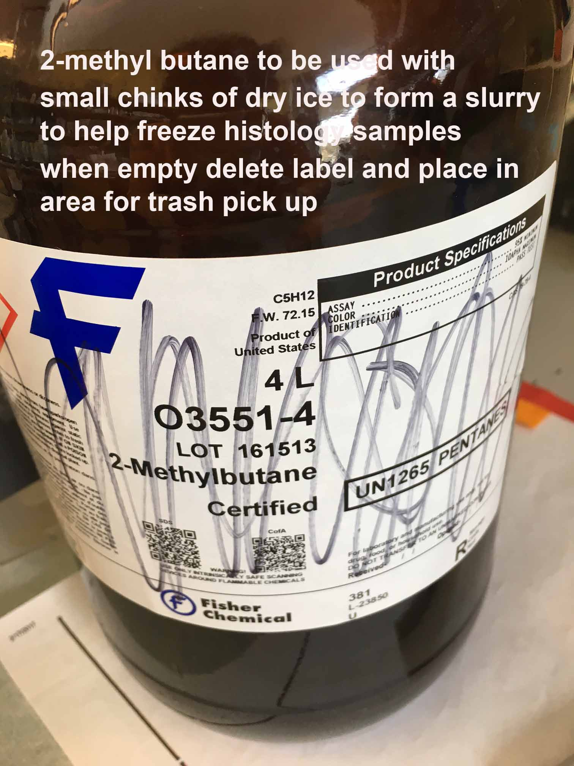
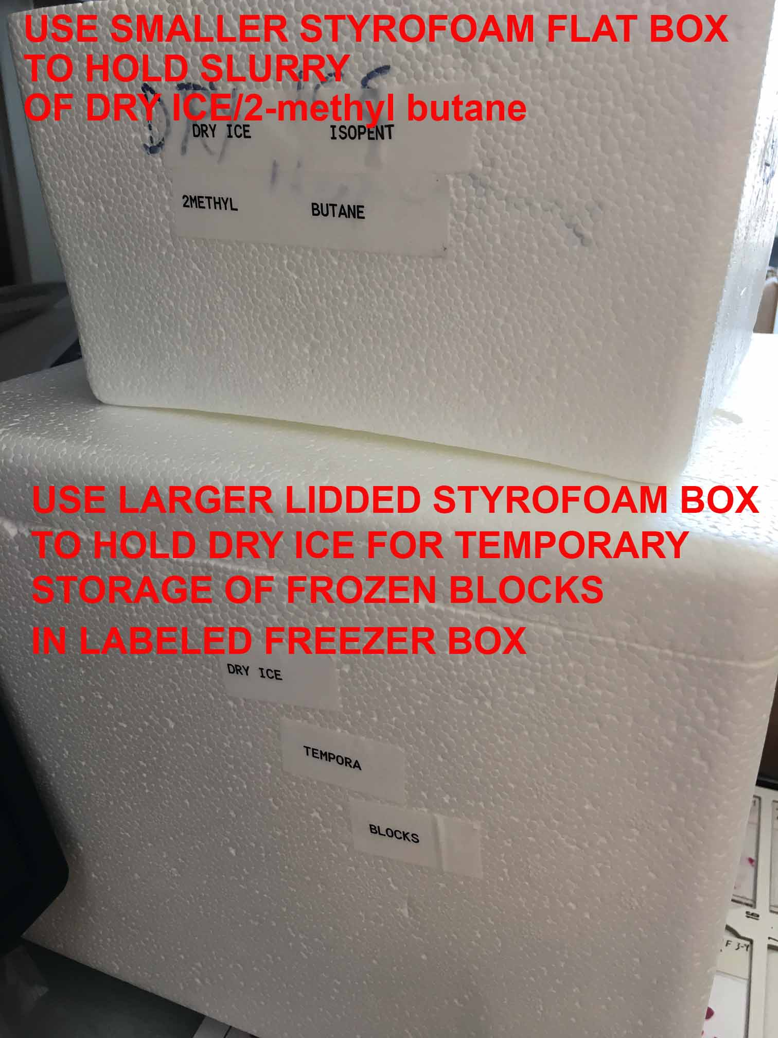
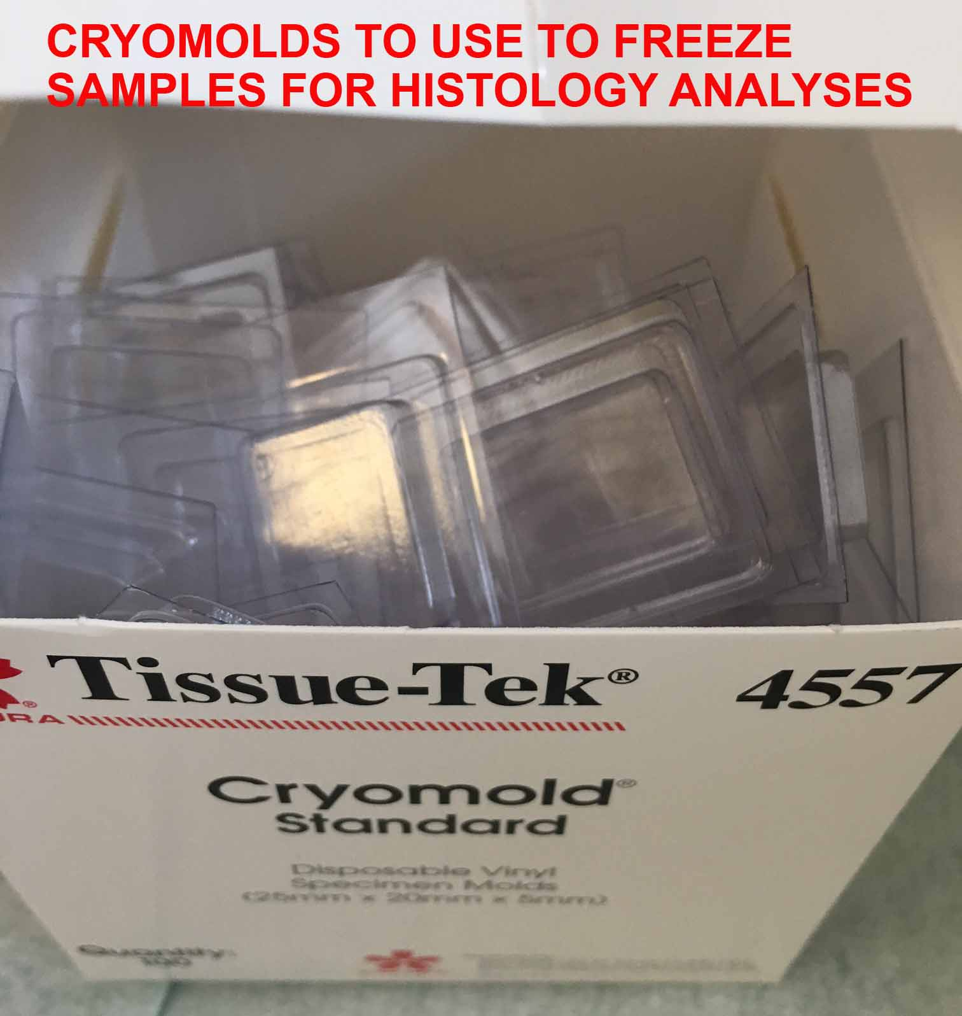

- Place larger blocks of dry ice in a separate Styrofoam container with the lid. The labeled freezer box will stay in this, holding the bags of frozen samples until they are transferred for long term storage in the minus eighty freezer
- Prepare 1:1 Mixture of OCT/PBS to inflate lungs before freezing in dry ice/ 2-methylbutane
- Prepare 1 ml syringes with needles for use to inflate the mouse lungs

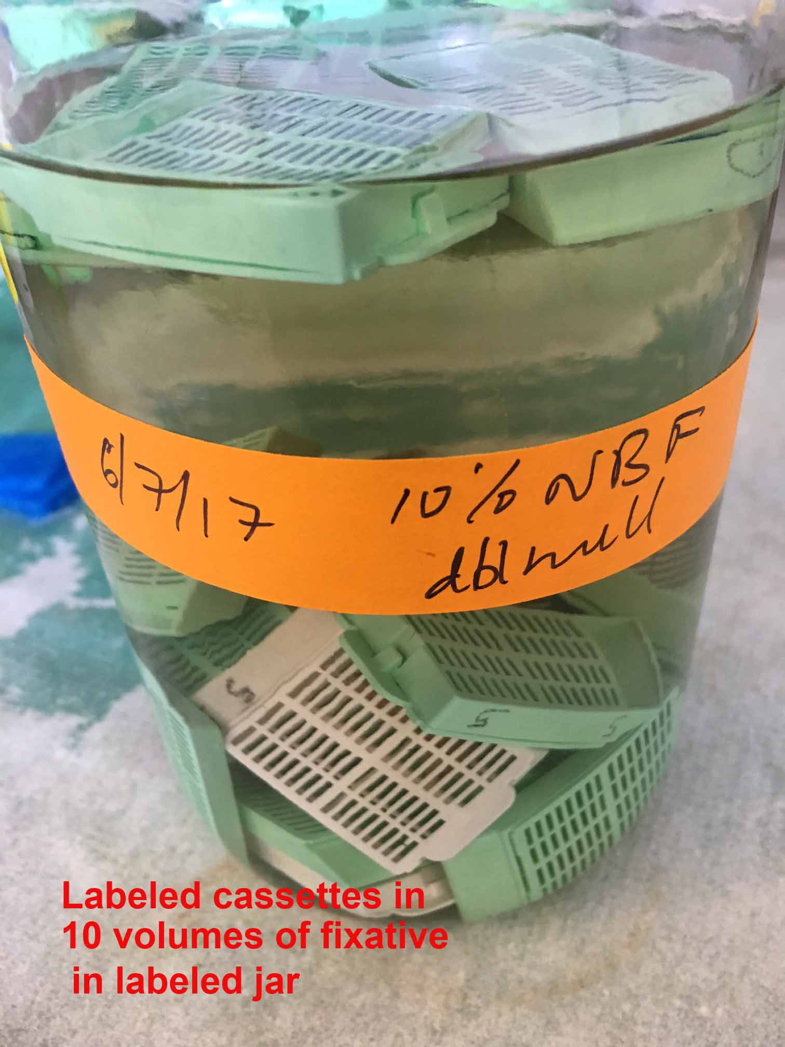
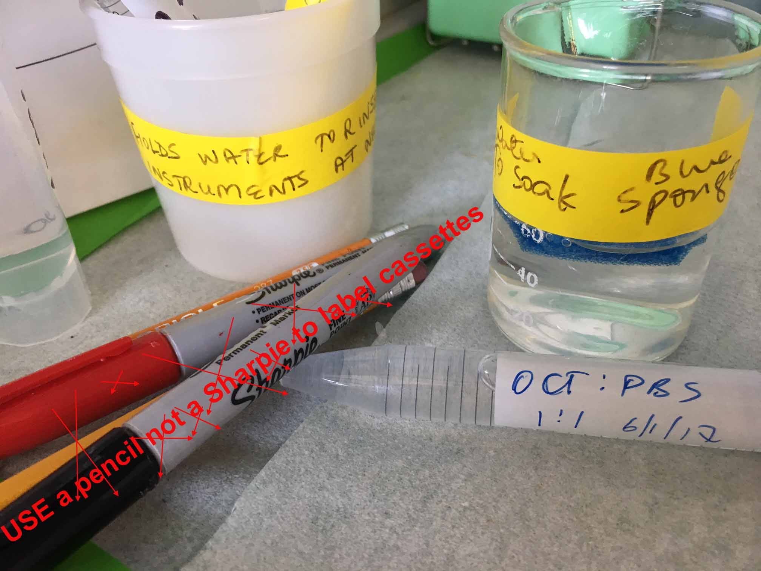

Prepare for Sample fixation:
- Label cassettes with animal # in front and Strain with date on the side and PI on other side. Finish labeling after placing organs from a particular animal DO NOT USE SHARPIES
- Label a different color cassette to contain BONE, since Bone needs to be fixed for a maximum of 24 hours, transferred to 70% alcohol and then into EDTA for decalcification before processing
- Prepare a small beaker with water to hold used instruments which will make it easier to wash blood off them
- Label another small container and add water and blue sponges to use in cassettes with spleen pancreas thymus
- Label a container to hold labeled cassettes containing samples to be fixed.
- Remember to change to 70% alcohol before 24 hours of fixation in 10% neutral buffered formalin

