UCSD Mouse Phenotyping Periodic Acid Schiff Stain (PAS)

Reagents:
- Periodic Acid (Fisher Scientific Cat# A223)
- Schiff’s Reagent (Fisher Scientific Cat# SS32)
- Hematoxylin 560 (Surgipath Cat#3801571)
- Scott’s Tap Water (Sigma Cat#S5134-6X100ML)
Preparation of Reagents:
- 1% Periodic Acid (1g/100mL of MQ water)
- Store Schiff’s Reagent at 4°C,
- But remember to take it out before periodic acid incubation, to adjust to room temperature .
Staining Method:
- Place slides in 1% Periodic Acid for 5 minutes
- Followed by 3 washes in DI water (10 dips each) and then dip in MilliQ water for 10 dips
- Immerse in Schiff’s Reagent for 15 minutes followed by Running tap water for 10 minutes
- Immerse in Gill’s Hematoxylin for 1 minute, followed by 3x DI water -10 dips each
- Immerse in Scott’s Tap Water for 30 seconds minimum, followed by 3x DI water -10 dips each
- Dehydrate and clear
Control Tissue:
- Colon (mucin staining)
- Liver (glycogen)
- Kidney (basement membranes )
Expected Appearance:
- Pink – Mucosubstances, glycogen, basement membrane
- Blue -- Nuclei
Note: May omit Hematoxylin step to see stronger distinction in basement membranes

Examples showing bright fuschia color in goblet cells of colon
After hematoxylin nuclear counterstain (left) and with no hematoxylin counterstain (right)
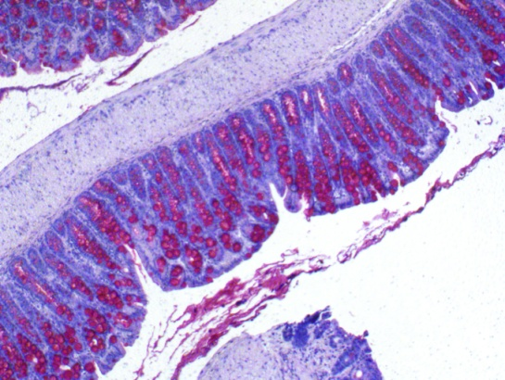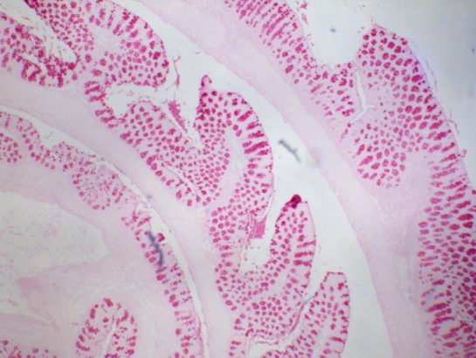

Reference: https://link.springer.com/protocol/10.1007/978-1-4939-7163-3_14

