UCSD Mouse Phenotyping Trichrome HistoChemistry (Masson’s Trichrome)

Reagents:
- Bouin’s Solution (Ricca Chemical Cat. #1120-32)
- Weigert’s Iron Hematoxylin Solution A (Harleco Cat. # 15204-220)
- Weigert’s Iron Hematoxylin Solution B (Harleco Cat. #15204-222)
- Bierbrich Scarlet-Acid Fuchsin Solution (Sigma Cat. #HT15-1)
- Phosphotungstic Acid Solution or PTA (Sigma Cat. #HT15-2)
- Phosphomolybdic Acid Solution or PMA (Sigma Cat. #HT15-3)
- Aniline Blue Solution (Sigma Cat. #HT15-4)
- Glacial Acetic Acid (Fisher Scientific Cat. #A38-500)
Preparation of Reagents:
- Prepare Weigert’s Iron Hematoxylin by diluting a ration of 1:1 , using Solution A and B (this solution can be reused for up to 2 weeks)
- Fresh Working Phosphomolybdic/Phosphotungstic Acid Solution is composed of 4 parts:
(1 part PMA, 1 part PTA, 2 parts MilliQ water): Now referred to as PMA/PTA Solution.
- 1% glacial acetic acid (in the Fume Hood, add 100mL of glacial acetic acid to 1L MQ water)
Staining Method:
- De-Paraffinize and re-hydrate sections on slides
- Place slides in the Fume Hood in a container of Bouin’s Solution, either overnight at Room Temperature OR for 1 hour in a 60°C oven.
- Place slides in a slide rack, in Running tap water, until the yellow color is washed away
- Place slides in a tub of Weigert’s Iron Hematoxylin solution for 5 minutes
- Wash slides in Running tap water for 5 minutes
- Rinse slides in DI water for 10 dips
- Place slides in Bierbrich Scarlet-Acid Fuchsin solution for 5 minutes
- Move slides to be rinsed 3x times in DI water , with at least 10 dips each
- Place slides in Working PMA/PTA Solution for 5 minutes
- Place slides in “Old” Aniline Blue for 1 dip (to prevent “contamination” of Aniline Blue with left-over PMA/PTA)
- Place slides in New Aniline Blue for 5 minutes
- Place slides in 1% Glacial Acetic Acid/MQ water for 2 minutes
- Move slides to be rinsed 3 times in DI water for 10 dips each
- Dehydrate and clear in xylene in the fume hood and mount using permanent mounting medium
Control Tissue:
- Colon or Lung
Expected Appearance:
- Blue – Collagen, Black – Nuclei, Red – Muscle Fibers , Red – Cytoplasm,
- Yellow – Everything Else
Notes:
- This histochemical stain is best when using paraffin sections,

An example image of mouse skin stained with Trichrome:

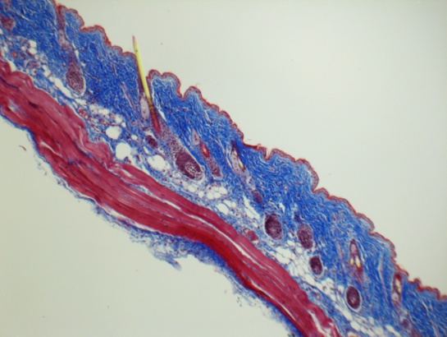

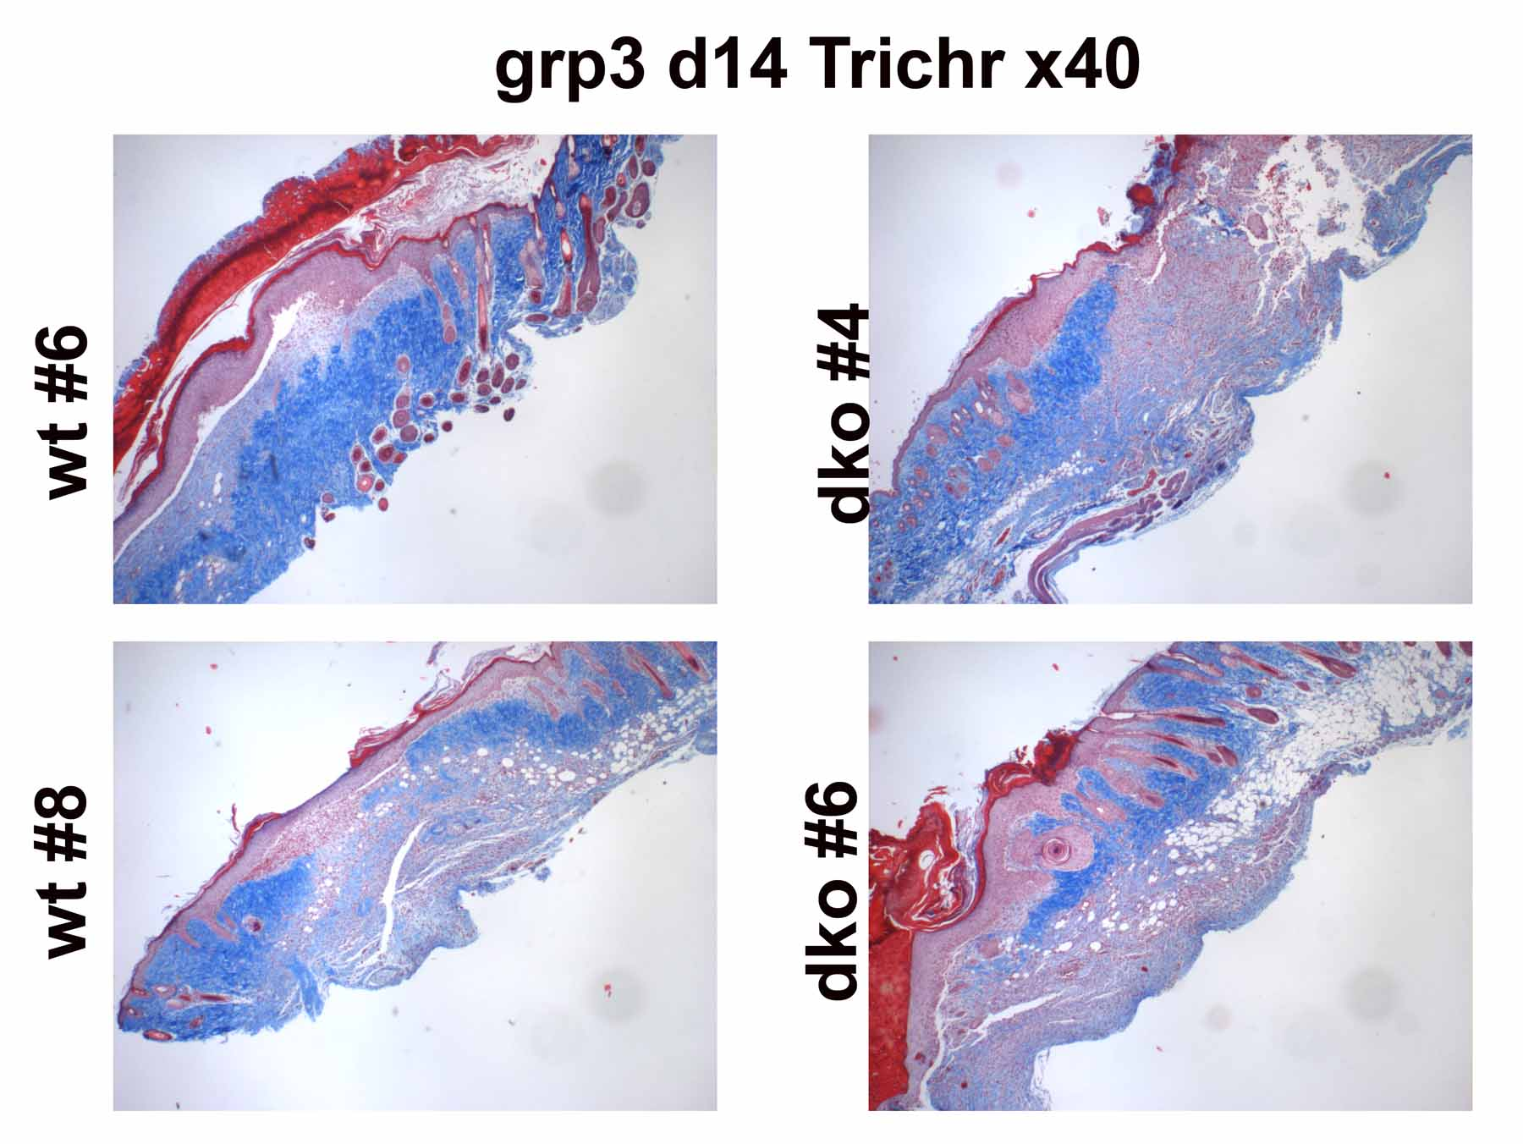
An example of Trichrome stains in paraffin sections of mouse skin, showing the blue staining of collagen in the dermis of mouse skin, to help quantify the scarring that occurs as part of the healing process after a wound.

