UCSD Mousephenotyping Picro-Sirius Red Histo-chemistry

Reagents:
- Direct Red 80 (Sigma Cat#365548-5G)
- 1.3% saturated picric acid solution (Sigma Cat# P6744-1GAL)
- Weigert’s Iron Hematoxylin Solution A (Harleco Cat# 15204-220)
- Weigert’s Iron Hematoxylin Solution B (Harleco Cat#15204-222)
- Glacial Acetic Acid (Fisher Scientific Cat#A38-500)
Preparation of Reagents:
- Weigert’s Iron Hematoxylin working solution: Mix 1:1 ratio of Solution A and B (this can be used for up to 2 weeks)
- 0.02% Picro-Sirius Red (0.1g Direct Red 80 in 500mL of 1.3% saturated picric acid solution): Can be used for 2-3 years
- 0.5% glacial acetic acid (50mL acid to 1L MQ water)
Staining Method:
- Deparaffinize paraffin sections and Place in slides Weigert’s Iron Hematoxylin for 8 minutes
- Move the sldies to Running tap water for 10 minutes
- Immerse slides in 0.02% Picro-Sirius Red for 1 hour
- Immerse slides twice (2x) in 0.5% Glacial Acetic Acid/MQ water -- 10 dips each
- Physically shake slides to remove the remaining water
- Dehydrate (100% EtOH only) and clear in xylene in the fume hood.
Control Tissue:
- Colon
- Lung
Expected Appearance:
- Red – Collagen
- Black – Nuclei
- Yellow – Everything Else
Notes:
- Works better on mouse tissue compared to Masson’s Trichrome
- Can differentiate between collagen via polarizer
- Larger fibers- yellow/orange
- Thinner fibers- green

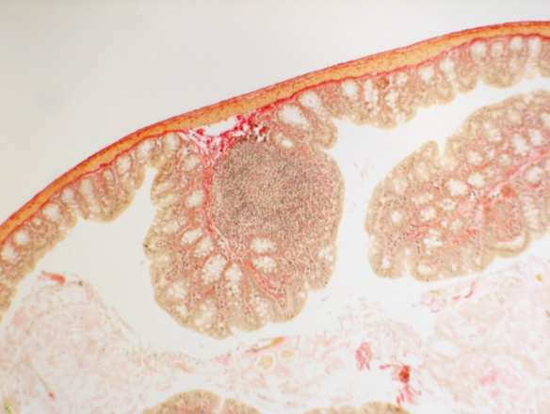
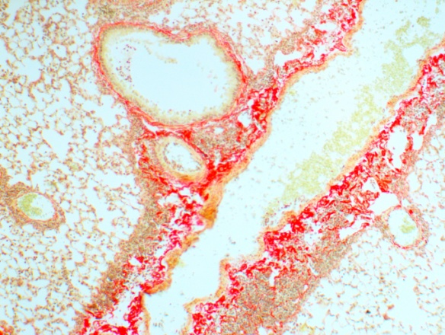
Example showing
Wild type mouse lung (left) and
Wild type mouse proximal colon (right)
with highlighted red collagen fibers, that can also be visualized using polarized light as well

