Plan for the necropsy so that it is efficient and before autolysis occurs—mouse organs die really quickly, and so using the following sequence of steps would help so that you can do one animal in about 15-20 minutes:

- Label cassettes with #2 pencil—so that the labeling does not disappear during processing. Label with a simple label—mouse ID in front, date on one side and PI name on the other side
- Fill to ¾ of volume, an empty about to be discarded tissue culture bottle with 10% neutral buffered formalin—there is a bottle in the fume hood at the end of Bay MM—but if you have some that will help
- Remember 10 volumes of fixative –the old tissue culture bottle will hold upto 20 cassettes
- Place blue sponges in the cassettes which will receive the spleen and pancreas, so that those organs, which tend to curl, will stay flat and thus easier for the histotechs to embed and thus obtain good flat sections
- Anesthetize and euthanize in the approved mouse chamber
- Spray carcass with 70% alcohol to prevent hair from flying around and causing allergies
- Insert scissors into the skin around the abdomen and Open using the Y-shaped incision
- Reflect the skin up above the chin and expose the salivary glands and dissect them out and place in labeled cassette. The same cassette can be used to hold the liver and the one half of each kidney.
So this cassette will hold the salivary glands, liver and kidney.
Salivary glands usually have lymph nodes attached udnerneath

- Hold the spleen and pull up to get the fatty looking pancreas. And place both in the cassette with the blue sponge.
So this cassette will hold spleen and pancreas
- Expose the trachea and inject about 1 ml of fixative into the lungs and you will get your thrill for the day when you see the lungs expanding. Remove the lungs—ideally you should separate out the lobes so you can look at pathology in each lobe
So one cassette for the lungs –and heart---—

Remember to separate the heart away and place in the cassette with the liver kidney salivary glands
- The intestines –small and large can be cut up into short segments—try to remove the fecal matter by squeezing the tube—this hardens during processing and it will be really challenging to the histotechs
So one cassette with the intestine—If you can see the Peyer’s patches—those will help with lymph node morphology

- Let the organs fix overnight and change to 70% alcohol and send to histology with the Request form filled out containing the chart string information.

References:
- https://www.ncbi.nlm.nih.gov/pmc/articles/PMC3211129/
- https://pubmed.ncbi.nlm.nih.gov/26331757/
- http://tvmouse.ucdavis.edu/virtualNecropsy/
- https://www.jove.com/v/10294/diagnostic-necropsy-and-tissue-harvest

In the next couple of pages, I have tried to show you how to do these steps—hope it helps
Help For mouse necropsy:

http://eulep.pdn.cam.ac.uk/Necropsy_of_the_Mouse/index.php?file=Chapter_4.html#1
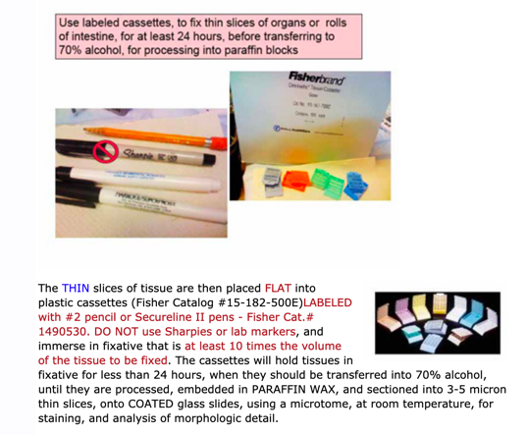
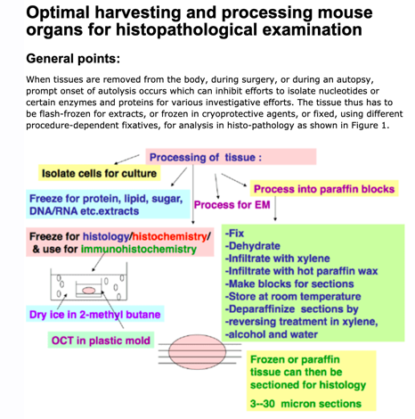

Use a #2 pencil to be sure none of the labels
wash off during processing in alcohol
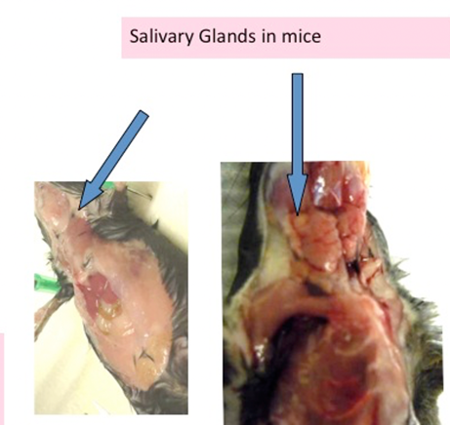
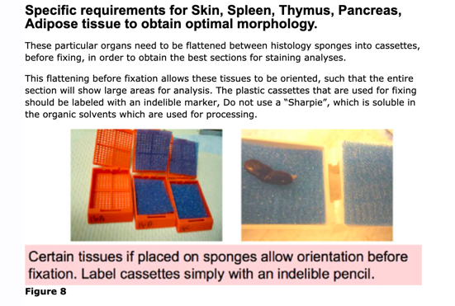

Flatten the spleen between sponges or it will curl up and they will not be able give you a good section to analyze

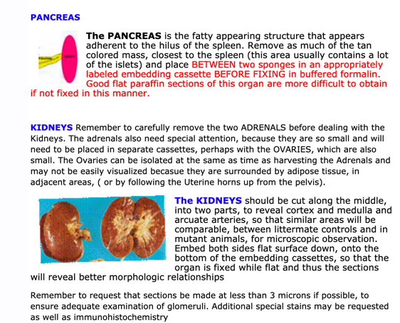
Mouse salivary glands are under the chin
right after you open up the skin

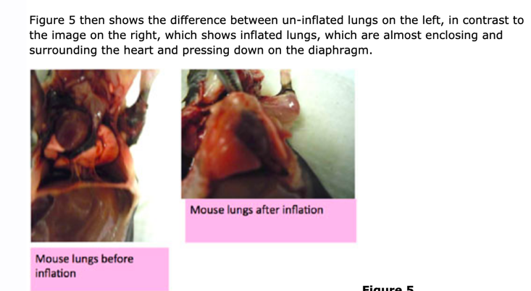

Slice each kidney in half
so that the section will go
through the middle to reveal any pathology
Inflate the lungs with fixative
for processing and paraffin embedding
or with 1:1 OCT: PBS for freezing

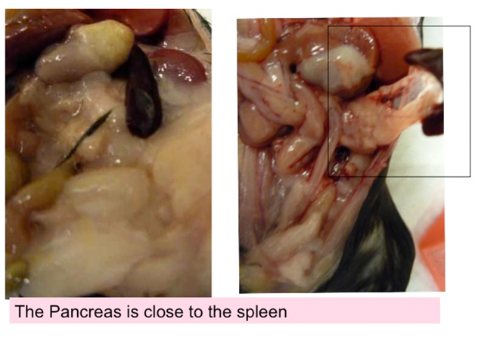
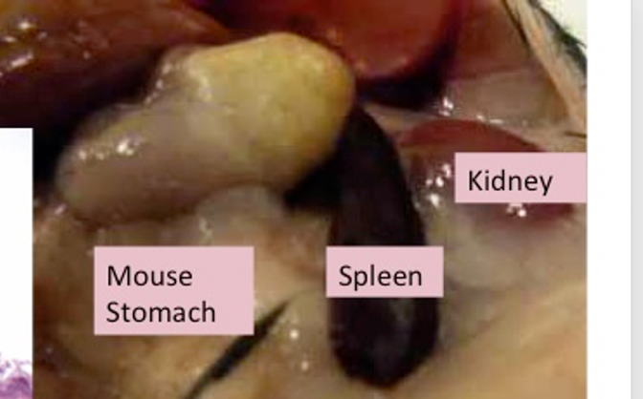

Pull up the spleen and the Pancreas is the fatty appearing organ attached to the spleen

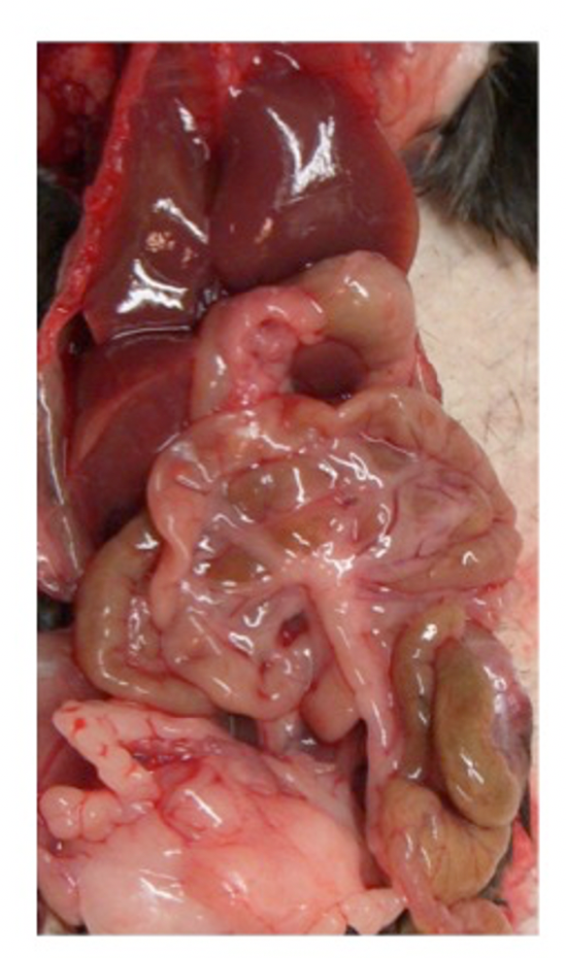
The mouse liver is under the diaphragm and the large organ which occupies the upper half of the abdomen you will see as you open the abdomen

Take the large lobe on top and place in the same cassette as the two halves of the kidneys

Pancreas and spleen go between sponges in a separate cassette

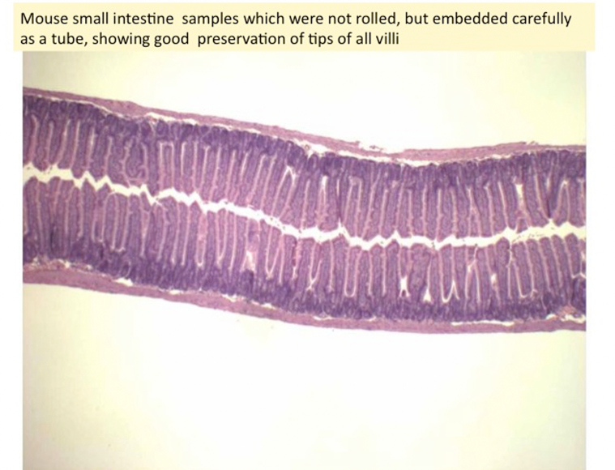

The intestines can be sampled as though they are
short segments of TUBES—
that is sufficient for a quick survey

