Oil Red O Histochemistry for frozen sections only

Reagents:
- Oil Red O (Sigma Cat. # O-0625)
- Isopropanol (Fisher Scientific Cat. # A451-4)
- Mayer’s Hematoxylin (Sigma Cat. # MHS80)
- 10% Neutral Buffered Formalin (Fisher Scientific Cat. # SF94)
- Vectamount Aqueous Mounting Medium (Vector Labs Cat. # H-5501)
Preparation of Reagents:
- Stock Oil Red O solution (make this at least a day or two prior to use)
  - Saturated Oil Red O in 99% Isopropanol (300mg of Oil Red O in /100mL isopropanol)
- Working Oil Red O solution
  - 30 mL of stock solution mixed with 20 mL of Distilled Water
  - Mix and let stand for 10 minutes.
  - Filter prior to use (takes about an hour to filter properly)
    - Use Whatman Paper (Cat# 1002-185)
- 60% isopropanol, diluted with MilliQ water
Staining Method:
- Air dry frozen sections on slides for 30 minutes minimum
- Fix in 10% neutral buffered formalin for 10 minutes
- Dip in 60% isopropanol 1 time quickly
- Stain in working Oil Red O solution for 15 minutes
- Dip in 60% isopropanol 1 time quickly
- Dip in DI water 1 time quickly
- Counterstain with Mayer’s Hematoxylin for 3 minutes
- DI water 10 dips
- Coverslip with aqueous mounting gel
  - IMPORTANT: Do not press on coverslips to remove air bubbles -> Lipids may move!
  - ALSO: Do not let air dry. Coverslip immediately after DI water.
Images: frozen sections of mouse liver stained with H&E (left panel) or Oil Red O (right panel)
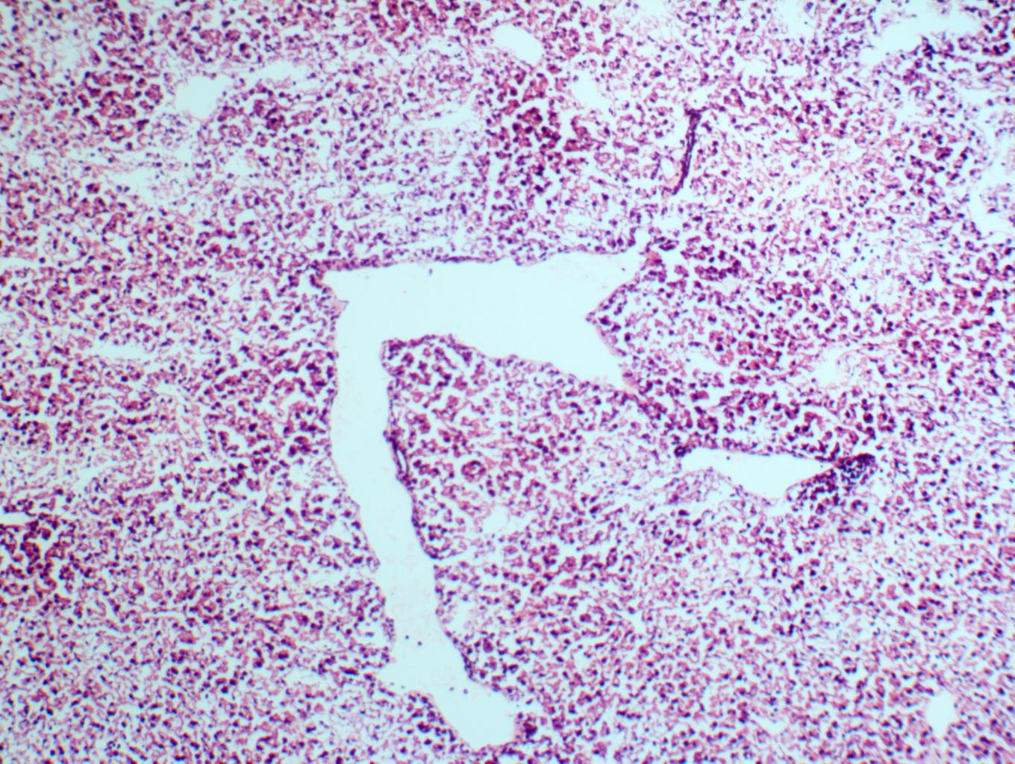
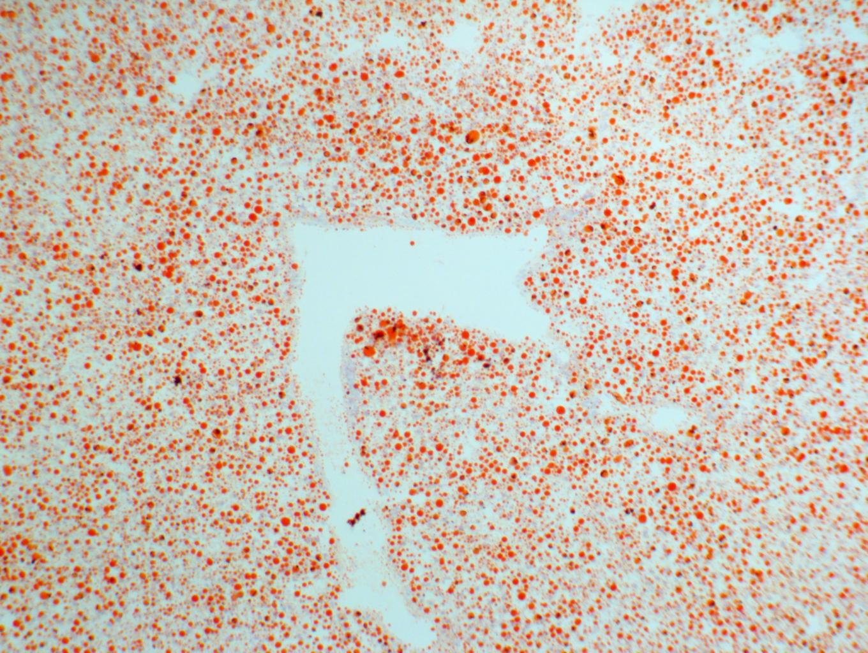
A: Oil Red O of SKF15 HF liver at 100x magnification
B: H&E of SKF15 HF liver at 100x magnification (same location)
C: Overlay of Figures A and B

